Go to CMC(<http://<ip address>:8080/BOE/CMC>):

Choose Access Level

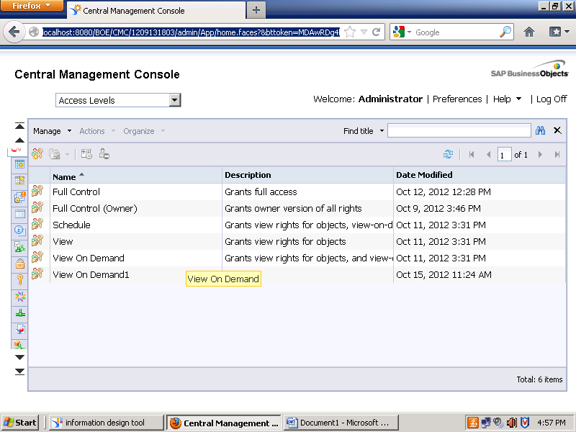

Choose View on Demand1--🡪Included Rights

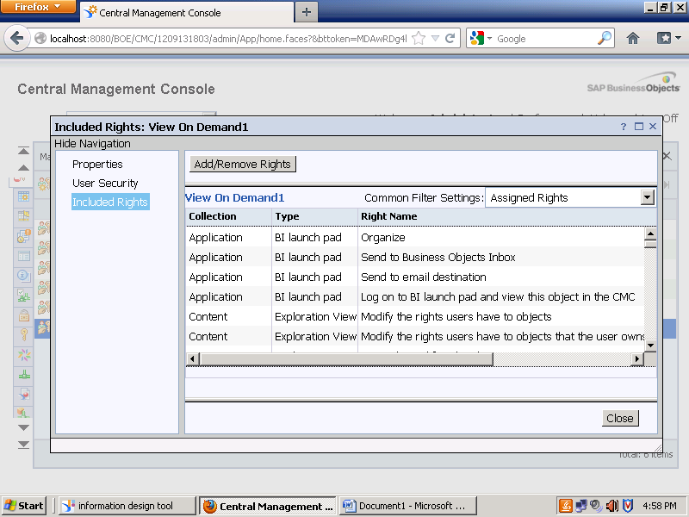

For Customisation :Click Add/Remove Rights

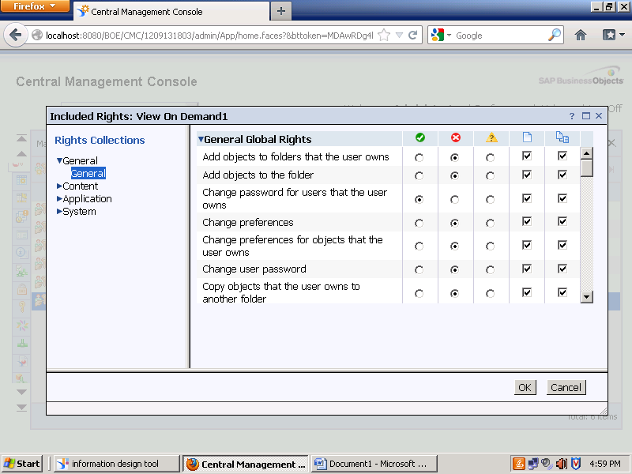

Users & Groups:

